1.0 | Commercial Product Name and Supplier
1.1 | Commercial product name / designation |  | Multi-Cal™ Calcium Hydroxide Paste
1.2  1.2.2  1.2.3 | Application / Use  SIC  Use Category |  | Dental material for use by dental professionals.  851 Human health activity  55
1.3 | Manufacturer  Pulpdent Corporation  80 Oakland Street, P.O. Box 780  Watertown, MA 02472 USA |  | Telephone: 1 617 926-6666 / Fax: 1 617 926-6262  Email: Pulpdent@pulpdent.com
1.4 | Emergency Telephone Number |  | 1-800-535-5053 (24 Hour / USA)
1.5 | Authorized European Representative |  | Advena Ltd.  Pure Offices, Plato Close  Warwick, CV34 6WE  United Kingdom
2.0 | Hazards Identification
2.1 | Classification
2.1.1 | Classification according to Regulation  (EC) No. 1272/2008 [CLP] | Hazard Class |  |  | Hazard Category | Hazard Statement
 |  | Skin irritation  Eye irritation |  |  | 2  2 | H315  H319
2.1.2 | Classification according to Directive 67/548/EEC  (See SECTION 16 for full text of risk phrases) |  |  | Irritant (Xi), R 36 / 38
2.2 | GHS Label Elements
Hazard Pictograms
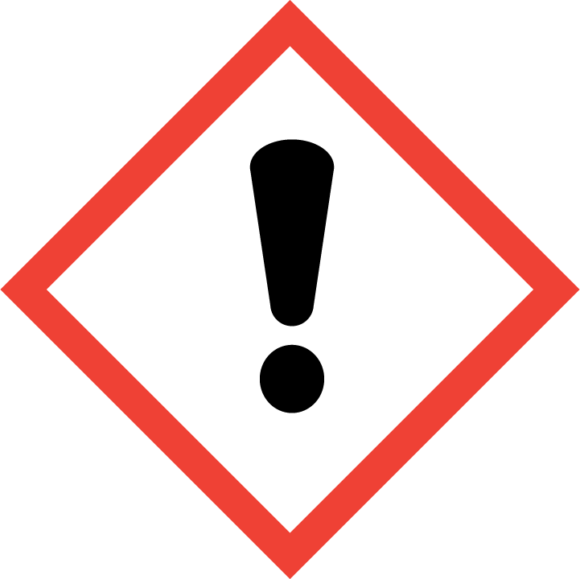
Signal Word: WARNING
Restricted to use by dental professional only.
Hazard Statements
H319: Eye irritation. 2. May cause eye irritation.
H315: Skin irritation. 2. May cause skin irritation.
Precautionary Statements
P280: Wear protective gloves and eye protection
P305+P351: If in eyes, rinse cautiously with water for several minutes.
P337+P313: If eye irritation persists, get medical advice/attention.
P302+P352: If on skin, wash with plenty of soap and water.
3.0 | Composition
3.1 | Chemical characterization of the preparation |  | Calcium hydroxide suspended in a cellulose/water gel matrix.

3.2 |  | Hazardous ingredients
 |  | CAS Number |  | Name of the Ingredient | Concentration |  |  |  | Classification per 67/548/EEC | Classification per Regulation (EC) No.1272/2008 (CLP).
 |  | 1305-62-0 |  | Calcium Hydroxide | 39% |  |  |  | Irritant (Xi)  R 36 / 38 | Skin irritation; 2  Eye irritation; 2
 | 4.0 |  | First Aid Measures
 | 4.1 |  | Special Instructions |  |  | Show this safety data sheet to medical personnel. Get medical attention in case of uncertainty. Calcium hydroxide-based preparations present minimal hazard in the quantities provided. May cause irritation on contact with eyes. Prolonged exposure may cause irritation to mucous membranes, skin, gastrointestinal or respiratory tract.
 | 4.2 |  | Eye Contact |  |  | Keep eyelids apart; flush with running water for 15+ minutes. Get medical attention.
 | 4.3 |  | Skin Contact |  |  | Remove any contaminated clothing. Wipe off excess from skin. Immediately flush skin water. Get medical attention if irritation persists.
 | 4.4 |  | Ingestion |  |  | Rinse mouth with water. Do not induce vomiting. Give large amounts of water to dilute. Get immediate medical attention for ingestion of large amount. Never give anything by mouth to an unconscious person.
 | 4.5 |  | Inhalation |  |  | Move to fresh air. If necessary, administer artificial respiration and seek medical attention.
 | 4.6 |  | Precautions for first responders |  |  | Wear safety glasses and gloves to prevent contact.
 | 4.7 |  | Information for physician
 |  |  | Symptoms |  |  | Irritation, pain or redness in eyes, on skin, on mucous membranes.
 |  |  | Hazards |  |  | May be irritating to eyes, skin, respiratory system, gastrointestinal tract or mucous membranes especially with prolonged exposure There is a risk of serious damage to eyes.
 |  |  | Treatment |  |  | Same as First Aid above.
 | 5.0 |  | Fire Fighting Measures
 | 5.1 |  | Suitable extinguishing media |  |  |  | Not a fire hazard. Extinguish fire with agent suitable for surrounding fire.
 | 5.2 |  | Extinguishing media to avoid |  |  |  | None
 | 5.3 |  | Special exposure hazards in a fire |  |  |  | None
 | 5.4 |  | Special protective equipment for fire-fighters |  |  |  | Self-contained breathing apparatus
 | 6.0 |  | Accidental Release Measures
 | 6.1 |  | Personal precautions. |  |  |  | Wear gloves, lab coat and chemical splash goggles.
 | 6.2 |  | Environmental precautions |  |  |  | None
 | 6.3 |  | Method for clean up |  |  |  | Wipe up/absorb with paper towels. Wash area of spill with water-saturated paper towels/cloths. Place spill and towels in container for disposal.

 | 7.0 |  | Handling and Storage
 | 7.1 |  | Handling |  | For use by dental professionals only. Wear gloves, safety glasses; wash hands after use. Avoid unnecessary exposure. Follow good hygiene practices. Do not smoke, eat or drink. Wash hands after use.
 | 7.2 |  | Storage |  | Remove applicator tip immediately after use. Keep tightly capped in original container. Store at cool room temperature. Avoid extremes of temperature (>27ºC/80ºF, <5ºC/40ºF) and acids.
 | 7.3 |  | Specific uses |  | Dental preparation
 | 8.0 |  | Exposure Controls / Personal Protection
 | 8.1 |  | Exposure limit values |  |  | Not available
 | 8.2 |  | Exposure controls |  |  | Wear safety glasses, lab coat and gloves. No other equipment required under normal conditions of use of this product in the quantity provided.
 | 8.2.1 |  | Occupational exposure controls |  |  | Wear safety glasses, lab coat and gloves..
 | 8.2.1.1 |  | Respiratory protection |  |  | Good general ventilation is sufficient to control any airborne vapors.
 | 8.2.1.2 |  | Hand protection |  |  | No special requirements other than the usual surgical gloves..
 | 8.2.1.3 |  | Eye protection |  |  | No special requirements other than the usual safety glasses..
 | 8.2.1.4 |  | Skin protection |  |  | No special requirements. Good personal hygiene, safety practices and wearing a lab coat should protect from unnecessary exposure.
 | 8.2.1.5 |  | Other controls |  |  | Emergency eye wash fountain. Wash hands after use.
 | 8.2.2 |  | Environmental exposure controls |  |  | Avoid release into environment as may cause pH variation.
9.0 |  | Physical and Chemical Properties
9.1 |  | Characteristics
9.1.1 |  | Appearance / Color / Physical state |  |  |  |  | White paste
9.1.2 |  | Odor |  |  |  |  | Odorless
9.2 |  | Important health, safety and environmental information
9.2.1 |  | pH |  |  |  |  | pH > 12
9.2.2 |  | Boiling point |  |  |  |  | Decomposes
9.2.3 |  | Flash point |  |  |  |  | Not combustible
9.2.4 |  | Flammability (solid, gas) |  |  |  |  | Not combustible
9.2.5 |  | Explosive properties |  |  |  |  | Not applicable
9.2.6 |  | Oxidizing properties |  |  |  |  | Not determined
9.2.7 |  | Vapor pressure |  |  |  |  | < 1 mm Hg (Id: A)
9.2.8 |  | Specific gravity |  |  |  |  | Not determined
9.2.9 |  | Solubility in water |  |  |  |  | Slight
9.2.10 |  | Partition coefficient |  |  |  |  | Not determined
9.2.11 |  | Viscosity |  |  |  |  | Not determined
9.2.12 |  | Vapor density |  |  |  |  | Not determined
9.2.13 |  | Evaporation rate |  |  |  |  | Not determined
10.0 |  | Stability and reactivity
10.1 |  | Conditions to avoid |  |  |  |  | Extremes of temperature (>27ºC/80ºF, <5ºC/40ºF).
10.2 |  | Materials to avoid |  |  |  |  | Calcium hydroxide reacts violently with maleic anhydride, nitro-ethane, nitro-methane, nitro-paraffin, nitro-propane, phosphorus. As a strong alkali, it is incompatible with acids.
10.3 |  | Hazardous decomposition products |  |  |  |  | Caustic fumes of calcium oxide when heated to decomposition.
10.4 |  | Further information |  |  |  |  | Stable under normal conditions.
11.0 |  | Toxicological information
11.1 |  | Acute toxicity |  |  |  |  | Not toxic. Minimal health hazard under normal conditions of use.
11.2 |  | Irritation and corrosiveness |  |  |  |  | Minimal health hazard under normal conditions of dental practice. Prolonged exposure may cause irritation of mucous membranes, eyes, skin, gastrointestinal tract or respiratory tract.
11.3 |  | Sensitization |  |  |  |  | Not applicable.
11.4 |  | Sub-acute, sub-chronic and prolonged toxicity |  |  |  |  | Narrowing of the esophagus may occur weeks to years after ingestion of large quantities, making swallowing difficult. Persons with pre-existing skin conditions may be more susceptible to the irritating effects of calcium hydroxide
11.5 |  | Carcinogenicity, Mutagenicity, Reproductive Toxicity |  |  |  |  | Not considered a carcinogen, mutagen or teratogen. Not toxic to the reproductive system.
11.6 |  | Empirical data |  |  |  |  | Not available
11.7 |  | Clinical Experience |  |  |  |  | Pulpdent calcium hydroxide preparations have been marketed to and used by dental professionals since 1947. Dentists’ experience with thousands of successful procedures is evidence of safe and effective dental treatment.
12.0 |  | Ecological Information
12.1 |  | Ecotoxicity |  |  |  |  | Not considered detrimental to water or soil. Avoid release into environment as calcium hydroxide may cause pH variation. Follow government regulations.
13.0 |  | Disposal Considerations
13.1 |  | Regulations |  |  |  |  | Follow all local and national government regulations in disposing material or contaminated packaging.
14.0 |  | Transport Information
14.1 |  | Restrictions |  |  |  |  | None. Not regulated.
14.2 |  | UN Number |  |  |  |  | None
14.3 |  | Technical name |  |  |  |  | Not applicable
14.4 |  | Packing group |  |  |  |  | Not applicable
 |  | IATA class |  |  |  |  | Not applicable
15.0 |  | Regulatory Information
15.1 |  | EU |  |  |  |  | Class IIa medical device under MDD 93/42/EEC.
15.2 |  |  |  | US FDA |  |  | Class II medical device
15.3 |  |  |  | Health Canada |  |  | Class III medical device
16.0 |  | Other information
16.1 |  | List of relevant R phrases |  |  |  |  | R 36 / 38: Irritating to eyes and skin.
16.2 |  | Hazard Statements |  |  |  |  | H319: Eye irritation. 2. May cause eye irritation.  H315: Skin irritation. 2. May cause skin irritation.
16.3 |  | Precautionary Statements |  |  |  |  | P280: Wear protective gloves and eye protection  P305+P351: If in eyes, rinse cautiously with water for several minutes.  P337+P313: If eye irritation persists, get medical advice/attention.  P302+P352: If on skin, wash with plenty of soap and water.
16.4 |  | Restrictions on use |  |  |  |  | Calcium hydroxide preparations are to be used only by dental professionals who have been trained in their use.
16.5 |  | Further information |  |  |  |  | The information presented herein is believed to be factual as it has been derived from the works of persons believed to be qualified experts. However, nothing contained in this information is to be taken as a warranty or representation for which Pulpdent Corporation bears legal responsibility. The user should review any recommendations in the specific context of the intended use to determine whether they are appropriate.
16.6 |  | Sources of key data |  |  |  |  | National Institute for Occupational Safety (NIOSH)  Occupational Safety and Health Administration (OSHA)  Eur-Lex European Union Law: Regulation (EC) No. 1272/2008 (CLP) and Regulation (EC) No. 1907/2006 (REACH).  Guidance on the compilation of safety data sheets. Version 1.1; December 2011. European Chemicals Agency
16.7 |  | Information which has been added, deleted or revised. |  |  |  |  | This Safety Data Sheet has been revised to meet the requirements of the GHS SDS format, Regulations (EC) No. 1272/2008 (CLP) and (EC) No. 1907/2006 (REACH). Specifically, Sections 2.1, 2.2, 3.2, 16.2, 16.3 have been modified.

